 **Universidad de Puerto Rico**

**Recinto Universitario de Mayagüez**

**Departamento de Ingeniería Eléctrica y Computadoras**

**Photo-Messaging-App**

**Phase II**

Carlos López Zayas – 841-14-3880

Ramón Rosado Rivera- 802-14-7210

Luis A. Rivera Márquez – 841-13-7000

**Dr. Manuel Rodríguez Martínez**

**ICOM 5016 – Introduction to Database Systems**

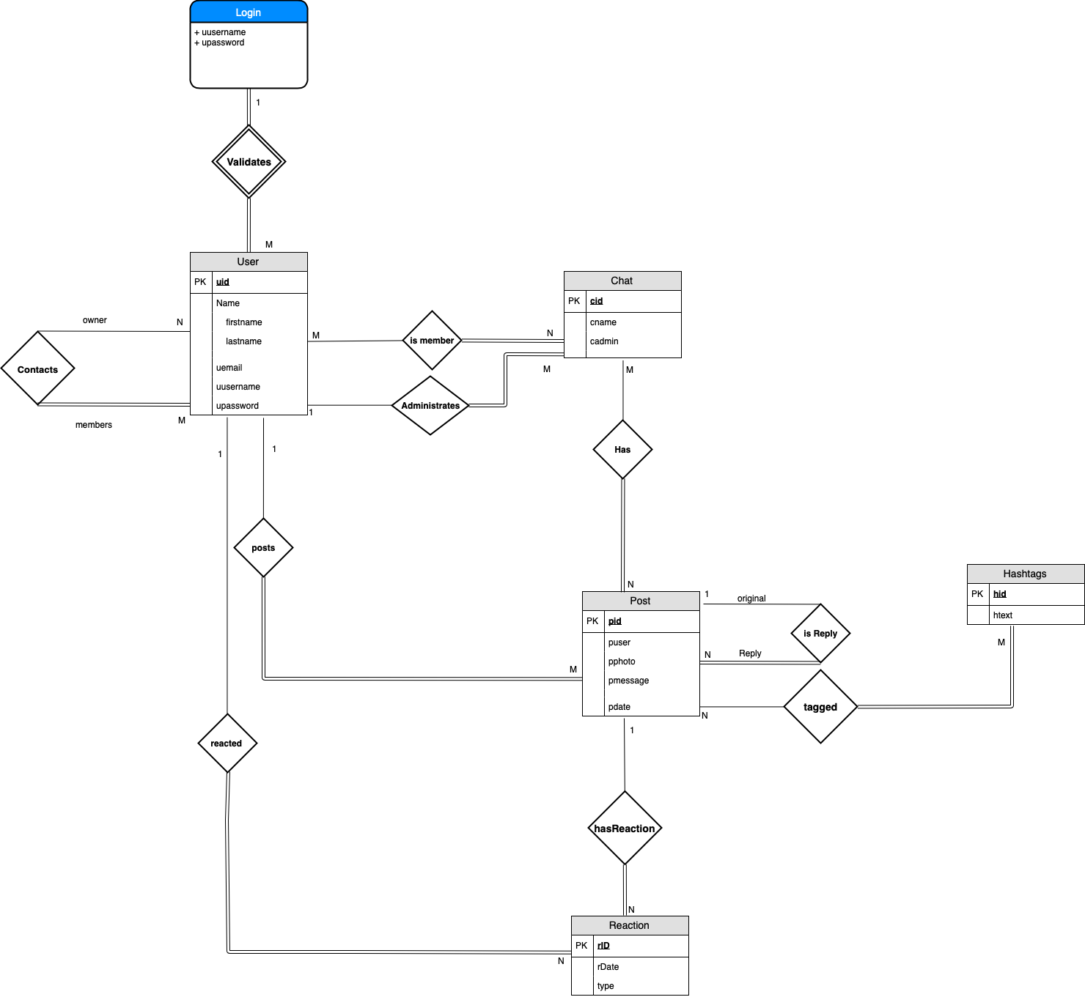*Not final version, still under changes.

**Entity – Relationship and Schema**

1. **Entities and Relationships**
2. **Users** - users in Photo-Messaging-App
3. uid: serial Primary Key
4. ufirstname: varchar(20)
5. ulastname: vachar(20)
6. uemail: varchar(20)
7. uusername:varchar(20)
8. upassword:varchar(20)
9. **Chat** – contains information related to a chat group
10. cid: serial primary key
11. cname: varchar(20)
12. cadmin:varchar(20)
13. **Post** – messages sent on chats
14. pid:serial primary key
15. pphoto:varchar(20)
16. pmessage:varchar(20)
17. pdate: varchar(20)
18. **Hashtags** – messages sent on chats
19. hid:serial primary key
20. htext:varchar(20)
21. **Reaction**– messages sent on chats
22. Rid:serial primary key
23. type:varchar(20)
24. rdate: DATE
25. **isMember** – user in chat
26. user_id interger references User(uid)
27. chat_id interger referenes Chat(cid)
28. primary key(user_id, chat_id)
29. **isReply** – replies in post
30. reply_id integer references Post(pid)
31. original_id integer references Post(pid)
32. original_id integer references Post(pid)
33. **has**- chat has posts
34. chat_id integer references Chat(cid)
35. post_id integer references Post(pid)
36. primary key(chat_id, post_id)
37. **login** – validates a user is registered
38. lid serial primary key
39. uusername varchar(20)
40. upassword varchar(20))
41. **validates** – relationship between login and user
42. login_id integer references Login(lid)
43. user_id integer references Users(uid)
44. primary key(login_id, user_id));
45. **contacts** – user are contacts
46. owner_id integer references Users(uid)
47. contact_id integer references Users(uid)
48. primary key(owner_id, contact_id)
49. **Tagged** – relationship between post and hashtags
50. post_id integer references Post(pid)
51. hashtag_id integer references Hashtag(hid)
52. primary key(post_id, hashtag_id)

**Mapping**

**create table Login**(lid serial primary key, uusername varchar(20), upassword varchar(20));

**create table Users**(uid serial primary key, ufirstname varchar(20), ulastname varchar(20), uemail varchar(50), uusername varchar(20), upassword varchar(20));

**create table Validates**(login_id integer references Login(lid), user_id integer references Users(uid), primary key(login_id, user_id));

**create table Contacts**(owner_id integer references Users(uid), contact_id integer references Users(uid), primary key(owner_id, contact_id));

**create table Chat**(cid serial primary key, cname varchar(20), cadmin integer references Users(uid));

**create table isMember**(user_id integer references Users(uid), chat_id integer references Chat(cid), primary key(user_id, chat_id));

**create table Post**(pid serial primary key, puser integer references Users(uid), pphoto varchar(30), pmessage varchar(100), pdate DATE);

**create table isReply**(reply_id integer references Post(pid), original_id integer references Post(pid), primary key(reply_id, original_id));

**create table Has**(chat_id integer references Chat(cid), post_id integer references Post(pid), primary key(chat_id, post_id));

**create table Reaction**(rid serial primary key, rDate DATE, type varchar(10), usr integer references Users(uid),  post integer references Post(pid));

**create table Hashtag**(hid serial primary key, htext varchar(30));

**create  table Tagged**(post_id integer references Post(pid), hashtag_id integer references Hashtag(hid), primary key(post_id, hashtag_id));